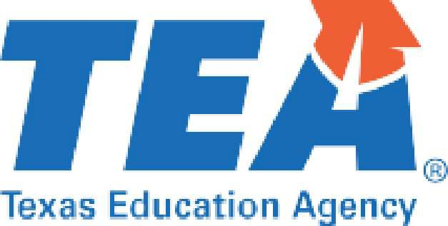

2022 Learn More About Your Child's School
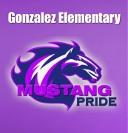

Dear parents and families,

As some of you may know, schools and districts will be rated this year. Schools and districts were labeled Not Rated: Declared State of Disaster for 2020 and 2021. Ratings are one of many ways to determine how well your child's school is preparing them for the next grade level and success after high school. Teachers and schools also use rating information to improve practices and instructional
approaches for the next school year and beyond.

Starting on August 15th, you will be able to view the rating for your child's school, plus much more, by visiting TXschools.gov . You will also be able to search for schools using your address and compare your child's school to others. Parents have shared that the detailed profile information along with school ratings, school offerings, and additional parent resources help paint a more complete picture of their child's school.

We encourage you to learn more about your child's school and use this information, your own observations, and your child's grades to create a learning plan to help your child succeed.

We wish you and your family a great school year.

For more information about school ratings, visit TXschools.gov .

